**CBI Finger Print IdentoGO**



Click on this FLAG

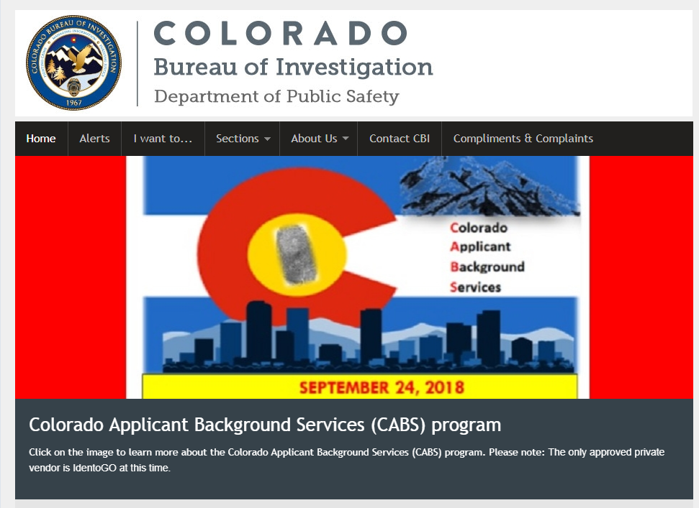

Takes you to this page

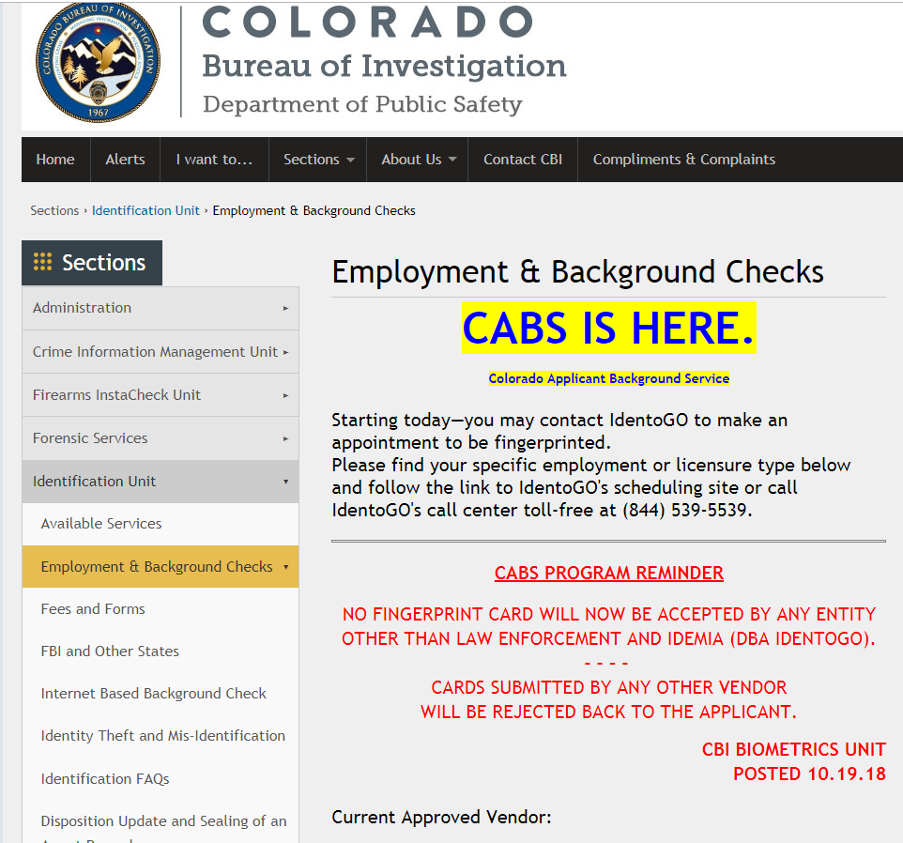

Scroll down GO PAST THIS

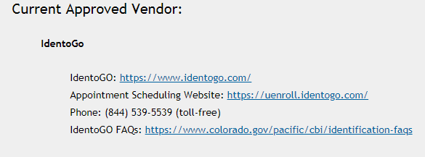

Scroll and SELECT THIS ONE

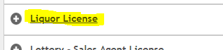

Next Page Select the Local (City/County Liquor Licensure Write down the Service Code 25YQHT

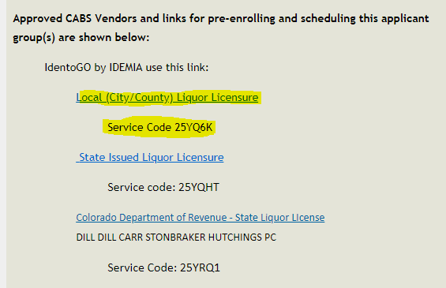

Next Page Make your selection

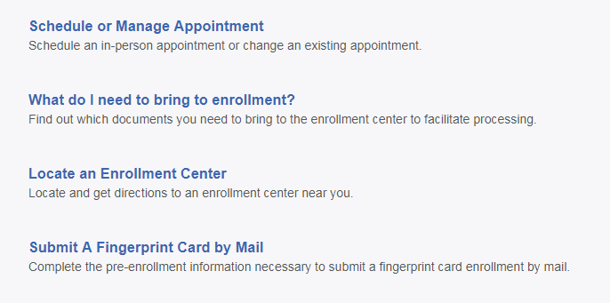

In this case Submit A Fingerprint Card by Mail

Pop Up Attention!

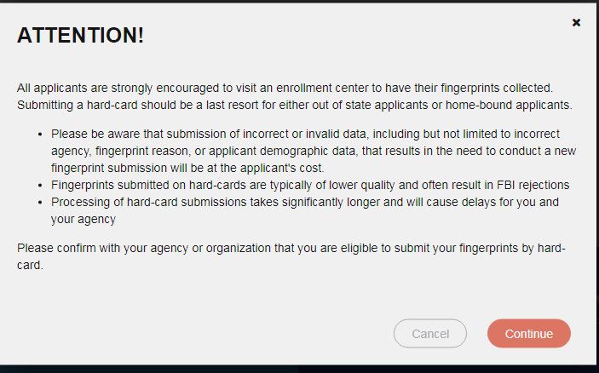

If you select continue…Fill out the information

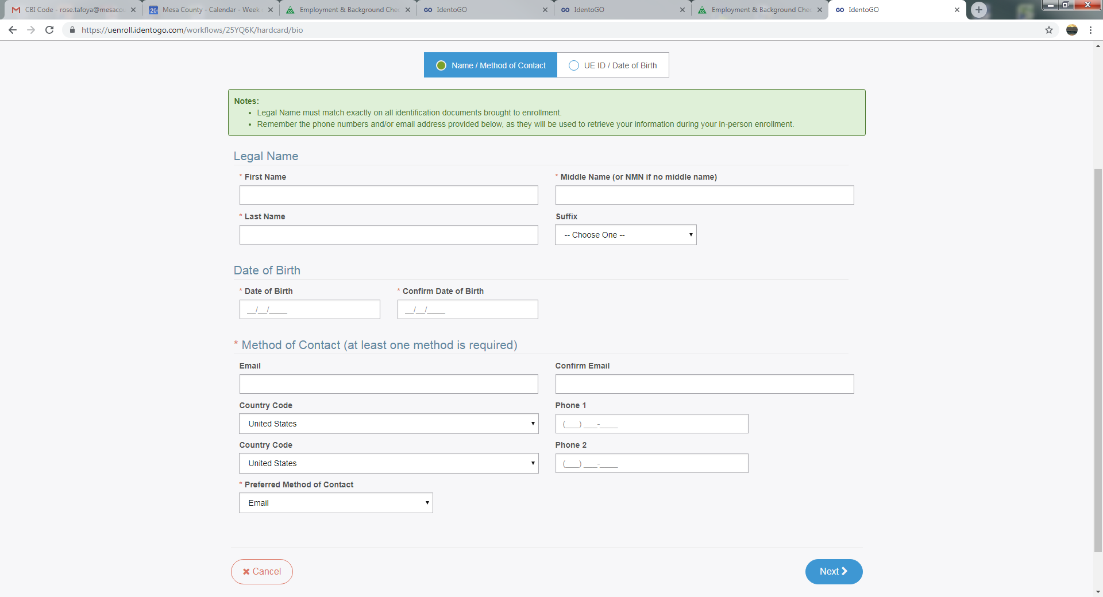

When you selcect the Next

This places you into the Facility page on this page is where you will use the Local Mesa County Sheriff Code CONCJ6012



You should be on your way to successfully submitting your fingerprint card via mail